**Basic Autohosted app for SharePoint**

**Description**

This sample hybrid app shows how to include a remote ASP.NET web application and classic SharePoint components in the same app for SharePoint.

It also shows how to use the SharePoint REST APIs to perform Read operations on SharePoint lists and list items, and how to retrieve only selected fields from the list. The app displays all of the items in a custom list that the app deploys to the app web.

The default.aspx page of the app appears after you launch the app and choose the **Get the Cast** button.

**Figure 1. default.aspx page in the app**

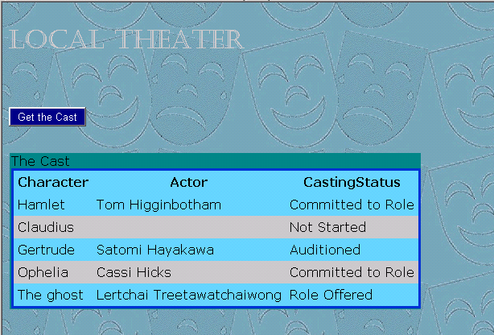

The sample demonstrates how to read data using the OData protocol from REST endpoints. Additionally, it demonstrates how to parse Atom-formatted XML returned from these endpoints by using the classes of the **System.Xml.Linq** namespace. (Other samples of apps for SharePoint show how to do this by using the classes of the **System.Xml** namespace.)

For more information about the SharePoint REST APIs, see the topic **Programming using the SharePoint 2013 Preview REST service** in the SharePoint 2013 Preview developer documentation. For more information about working with Atom and OData, see [ODataHYPERLINK "http://www.odata.org/developers/protocols/atom-format": HYPERLINK "http://www.odata.org/developers/protocols/atom-format"AtomPubHYPERLINK "http://www.odata.org/developers/protocols/atom-format" Format](http://www.odata.org/developers/protocols/atom-format).

**Prerequisites**

* A SharePoint 2013 Preview development environment that is configured for app isolation and OAuth.
* Visual Studio 2012 and SharePoint development tools in Microsoft Visual Studio 2012.

**Important contents**

* TheaterCompany project, which contains the AppManifest.xml file, the feature.xml file, and various XML files that define the SharePoint components.
* TheaterCompanyWeb project.
* Default.aspx file, which contains the HTML and ASP.NET controls for the user interface of the app.
* Default.aspx.cs file, which contains the C# code that uses the REST APIs to read data.
* Web.config, web.debug.config, and web.release,config files. (The web.config file that is packaged with the app is a merger of web.config and either web.debug.config or web.release,config.)

**Configuration instructions**

* Open the TheaterCompany.sln file in Visual Studio.
* In **Properties** pane of Visual Studio, change the **Site URL** property of the app for SharePoint project in Visual Studio to the absolute URL of your SharePoint 2013 Preview developer test site. For example, "[http://MyDevServer/sites/MyTestSite](http://mydevserver/sites/MyTestSite)".

**Build instructions**

* Choose the top solution node **TheaterCompany** in **Solution Explorer**. On the menu bar, choose **Build**, **Build Solution**.

**Deploying and testing the sample**

* Choose the F5 key. The web application, **TheaterCompanyWeb,** is deployed to IIS Express at the URL specified in the SSL URL property of the project. The **TheaterCompany** app is installed to your test SharePoint website. (The remote app does not try to interact with the host web, and the app principal automatically has permissions to the app web, so you are *not* prompted to grant permissions.) The **Site Contents** page of your target SharePoint website opens, and you can see the new app listed there.
* Choose the **Theater Company** app, and the remote web application opens to its default page. Depending on your browser, there may or may not be a background with the classic comedy and tragedy masks as shown in Figure 1. If the browser cannot open the background file, a sea green background is seen. Choose the **Get the Cast** button. A grid that is partially populated with data should open, as shown in Figure 1.

**Change log**

First release.

**Related content**

[Open Data Protocol](http://www.odata.org/)

[ODataHYPERLINK "http://www.odata.org/developers/protocols/atom-format": HYPERLINK "http://www.odata.org/developers/protocols/atom-format"AtomPubHYPERLINK "http://www.odata.org/developers/protocols/atom-format" Format](http://www.odata.org/developers/protocols/atom-format)

SharePoint 2013 Preview SDK topics:

**How to: Create a cloud-hosted app that includes a custom SharePoint list and content type**

**Programming using the SharePoint 2013 Preview REST service**

**Contact info**

DocThis@microsoft.com